1. Factor completely each of the following: First consider the methods you have become very familiar with

(GCF, Difference of Perfect Squares, Trinomials), and then consider grouping methods using “M

substitutions” where helpful.

a.  b. 

c.  d. 

e.  f. 

h.  i. 

j.  k. 

l.  m. 

n.  o. 

2. Between what two consecutive integers does the largest root of  lie?

3. Solve the following equations. Leave your answers in simplest radical form if needed.

a.  b. 

c.  d. 

e.  f. 

4. Let  and . Find all values of *x*, for which 

a. ***algebraically* b. *graphically***

5. Sally tossed a ball in the air in such a way that the path of the ball was modeled by the equation

. In the equation, *h* represents the height of the ball in feet and *t* is the time in seconds.

***All*** work must be done ***ALGEBRAICALLY*** (or NO credit will be given).

1. What was the initial height of the ball? b. At what time is the ball at its highest point?

c. What is the maximum height of the ball?

d. After how many seconds did the ball reach 20 feet?

e. After how many seconds does the ball hit the ground? Round your answer to the *nearest hundredth*.

6. Solve each of the following quadratic inequalities. Express the solution set in interval notation.

a. 

b. 

c. From June 2003 until April 2004 JetBlue airlines stock (JBLU) was approximately worth

 where *P* denotes the price of the stock in dollars and *t* corresponds to months, with  corresponding to January 2003. During what ***months*** was the stock value at least $36.

7. Place each of the quadratic functions in vertex form. Identify the turning point.

a.  b. 

c.  d. 

8. For each of the following equations of circles, determine both the circle’s center and its radius. If its radius

is not an integer, express it in decimal form rounded to the nearest *tenth*.

a.  b.  c. 

d.  e.  f. 

9. Solve the following system of equations ***graphically and algebraically***:

*x*

*y*



10. By completing the square on each of the quadratic expressions, determine the center and radius of a circle whose equation is shown below.

a.  b. 

11. Given a parabola whose directrix is  and whose focus is , find the following

*x*

*y*

a. The vertex of the parabola b. The equation of the parabola in ***vertex form***.

12. Given a parabola whose directrix is  and whose vertex is , find the following

*x*

*y*

a. The focus of the parabola b. The equation of the parabola in ***standard form***.

13. Given a parabola whose focus is  and whose vertex is , find the following

*x*

*y*

a. The directrix of the parabola b. The equation of the parabola

14. Which equation represents a parabola with a focus of  and a directrix of 

*x*

*y*

1.  (3) 
2.  (4) 

15. Write the equation of the function, and its domain,  after each of the following transformations:

a. shifted to the left 3 units b. shifted down 4 units

c. shifted to the right 2 units and up 3 units d. a vertical stretch by a factor of 5 and shifted down 6

units.

e. vertically compressed by a factor of 2

and shifted up 3 units.

f. horizontally stretch by a factor of 2

g. horizontally compressed by a factor of 3 and shifted down 4 units.

16. The graph of  is show below on two separate grids. Give an equation and sketch a graph for the functions (a)  and (b) .

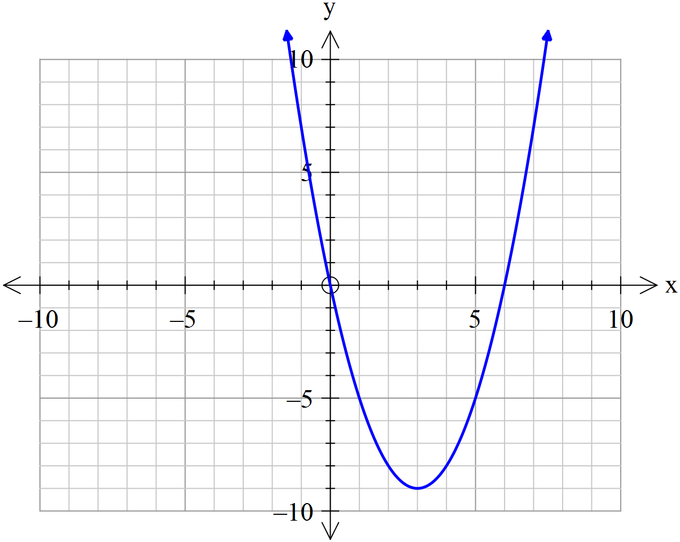

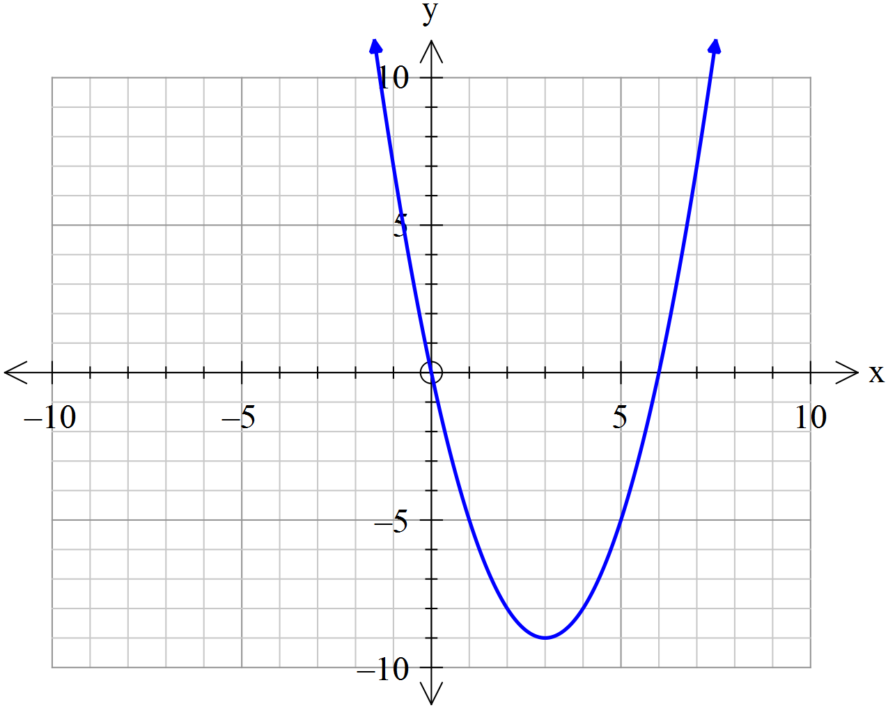

17. If  and ** is the reflection of  across the *y*-axis, write an equation of *.*

18. If the point  lies on the graph of a function  then what point *must* lie on the graph of the

function 

19. The graph of  represents the graph of  after

(1) a vertical shift upwards of 8 units followed by a reflection in the *x*-axis.

(2) a reflection in the *x*-axis followed by a vertical shift of 8 units upward.

(3) a leftward shift of 8 units followed by a reflection in the *y*-axis.

(4) a reflection across the *x*-axis followed by a rightward shift of 8 units.

20. If the function  were graphed, write the transformations to the graph of  in the order that they occur.



21. The graph of  is shown below. Consider the function 

defined by .

a. What two transformations have occurred to the graph of *f* in order

***y***

***x***

to produce the graph of *g*? Specify both the transformations and their order.

b. Graph and label 

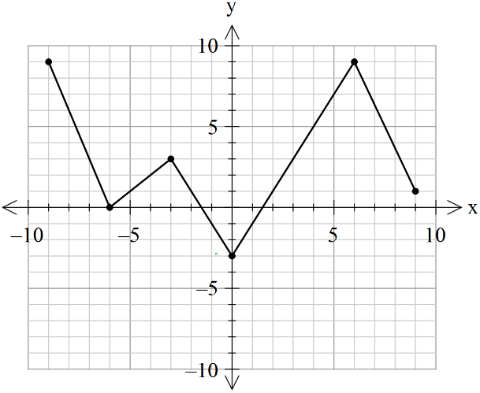22. The graph of  is shown on the grid below. Sketch a graph of  on the same set of axes.

State the domain of the two functions:

Domain of : Domain of :

23. If  is an even function and  then what is the value of ?

24. If  is an odd function and  then what is the value of 

25. Algebraically determine if each of the following functions are even, odd or neither.

(a)  (b) 

(c)  (d) 

(e)  (f) 

(g)  (h) 

26. State the domain of each function.

a.  b.  c. 

d. f(*x*) =  e.  f. t(*x*) = 

g.  h. i. 

*x*

*y*

j.  k.  l.

27. Expressed with fractional exponents,  is equivalent to  27. ________

(1)  (2)  (3)  (4) 

28. Place each of the following power functions in the form .

a.  b.  c.  d. 

29. Simplify each of the following:

a.  b.  c. 

30. Solve for *x*:

a.  b. 

c.  d. 

31. Solve each of the following quadratics using the quadratic formula leave your answer in simplest radical form.

a.  b.  c. 

32. A projectile is fired from a height of 4.5 meters above the ground of a level surface at an initial upwards velocity of 30 meters per second. Its height above level ground is given by the equation . After how many seconds, t, will the ball hit the ground. Find using the quadratic formula and round to the nearest tenth of a second.

33. Simplify each of the following:

(a)  (b)  (c)  (d) 

(i)  (j)  (k)  (l) 

34. Perform the indicated operations below and leave each answer in simplest form

(a)  (b)  (c) (d) 

(e) 

35. Solve the equation  over the set of complex numbers. Put your answers in simplest form.

# Summary of the Discriminant

**Discriminant Roots of Equation x-Intercepts**

**1.  and perfect square Two unequal real, rational roots. Two rational x-intercepts**

**2.  One real, double root. One rational x-intercept. (tangent to x-axis)**

**3.  and not a perfect square Two unequal real, irrational roots. Two irrational x-intercepts**

**4.  Two imaginary roots. No x-intercept**

36. Select the choice below that describes the graph of the given parabolas below:

(1) It is tangent to the x-axis (3) It intersects the x-axis at 2 points

(2) It lies entirely above the x-axis (4) It lies entirely below the x-axis

a.  b.  c.  d. 

37. Select the choice below that describes the nature of the roots of the given equations below:

(1) real, rational, and unequal (3) real, rational, and equal

(2) real, irrational, and unequal (4) imaginary

a.  b.  c.  d. 

38. Find all values of k such that the equation  has imaginary roots.

39. Find the largest integer value of k that makes the graph of  cross the x-axis twice.

40. Find the smallest integer value of k such that the equation  has imaginary roots.

41. Find the value(s) of k that make the graph of  tangent to the x-axis.

42. The roots of a quadratic equation may be: 42. ________

(1) rational and equal (2) irrational and equal (3) imaginary and equal (4) none of these

43. Which of the following could not be the solution of a quadratic equation? 43. ________

(1) {-3} (2) {2, -3} (3)  (4) 

44. Which equation has imaginary solutions? 44. ________

(1)  (2)  (3)  (4) 

45. Which equation has roots that are real, rational, and equal? 45. ________

(1)  (2)  (3)  (4) 

46. If the roots of the equation  are real and irrational, the value of c may be 46. ________

(1) 1 (2) 2 (3) 0 (4) -1

47. The roots of the equation  are real and equal if a has a value of 47. ________

(1) 1 (2) 2 (3) 3 (4) 4

48. Which value of k will make the roots of  imaginary? 48. ________

(1) -2 (2) 2 (3) 3 (4) -3

49. Could the following graph be that of a cubic function?

Explain your answer.

50. The cubic polynomial shown below crosses the x-axis at  and is tangent to the x-axis at . It has a turning point at . Find the equation of the cubic function below in standard form.







51. What are the solutions of the equation 

52. What are the solutions of the equation 

53. What are the factors of the polynomial expression *x*3 + 2*x*2 – 5*x* – 6?

54. Find the equation of the cubic function of the form y = *x*3 + b*x*2 + c*x* + d if its *x* intercepts are {-1, 3, 5}.

55. Graphically solve the equation *x*4 + 2*x*3 – 21*x*2 – 22*x* + 40 = 0.

56. Given that  is a factor of , find the other two factors algebraically.

57. Write the following rational function in its quotient-remainder form:



58. Find the inverse of each of the following functions.

(a)  (b)  (c) 

59. Solve each of the following fractional equations. Be sure to check for extraneous roots.

a.  b. 

c. 

60. Solve each of the following rational inequalities. Use any appropriate notation and graph your solution on a number line.

a.  b. 

c. 

61. Determine the power function in each polynomial that describes the polynomial’s long-run behavior.

a.  b.  c. 